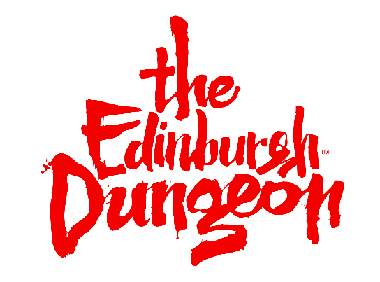

Risk Assessment Form: The Edinburgh Dungeon*
About The Edinburgh Dungeons
The Edinburgh Dungeon is a 70-minute journey into more than 2000 years of Edinburgh’s horrible history. The Dungeon brings together an amazing cast of theatrical actors, special effects, stages and scenes in a truly unique and exciting walkthrough experience that you see, hear, feel and smell. It’s hilarious fun and it’s sometimes a bit scary.
Everything you see is based on real historical events from Dr Knox’s anatomy theatre to the Judges courtroom. The Edinburgh Dungeons is bolder and better than ever, with 10 live shows that are make us the black comedy of attractions; dark, atmospheric and very funny.
About Merlin Entertainments
Merlin Entertainments Group is the largest European entertainments company operating in Europe. Merlin runs 123 attractions in 24 countries across four continents. Our aim is to deliver unique, memorable and rewarding experiences to millions of visitors across our growing estate. We believe that we achieve this objective largely thanks to the commitment and passion of our team and the strength of our brands, which will never fail to be distinctive, challenging and innovating. In every respect and to every group of stakeholders, Merlin will always be an exciting company to be involved with.

Legal Requirements and Attraction Information
Public Liability | Merlin Entertainments Group Limited & Subsidiary Companies are covered by Public Liability Insurance to the amount of £10 million. The Policy is with the ACE European Group Ltd (Policy No UKCANC33447).
Local Enforcement Agency | The Edinburgh Dungeon site is enforced by the local Health and Safety Executive and Environmental Health Department. Please contact the Manger of the Dungeon if you require further information.
Food Safety and Hygiene | No food or drink can be consumed in Edinburgh Dungeon.
Attraction Staff/Staff Identification | Apart from the office areas, all staff wear uniforms and name badges. Please be aware that some staff will be in costume without name badges. A policy exists the staff who deliver workshops and city tours will have additional DBS checks.
Security | The attraction has a dedicated crisis team who are able to deal with minor security issues on site. The team is also trained to deal with emergency incidents that may arise.
Risk Assessment  Weather Protection/Sun Safety | Other than admissions the of the Edinburgh Dungeon tour, the entire experience is indoors so weather protection is not required. If a school has booked on a city tour, an inspection of the weather will be carried out by The Edinburgh Dungeon staff and the school. However, please contact the Health and Safety Officer for more details.
Water | There are no immediate water hazards during the tour of The Edinburgh Dungeon; however, during the city tour the route takes place at the side of a river. Please contact the Health and Safety Officer for more details.
Slips/Trips/Falls | The following hazards should be noted:  - Trips caused by looking at the display not the floor  - Wet flooring  - Steps and stairs
High Level Areas | Supervision is required.
Strobe Lighting | Strobe lighting effects may be used throughout.
Reduced Lighting | Care should be taken due to reduced lighting.
Enclosed Spaces | There are enclosed spaces throughout; however, there are no areas in the attraction that can be defined as confined spaces.
Attraction Specific Risk | Tampering with any electrical equipment is prohibited and supervision is required. Due to the content of the exhibitions care must be taken to assess the suitability of young children for exposure to this type of attraction.
Door Entrapment | Beware of closing doors on fingers etc.

Attraction Arrangements

Arrival Arrangements | You can arrive anytime within your booked time slot. Tours star approximately every 10 minutes.
Parking | The two nearest car parks are Q-Park Omni Car Park EH1 3AN & Edinburgh Waverely Car Park Apcoa EH1 1BB
First Aid | The venue has medical/first aid facilities which are operated by a dedicated team of qualified first aiders.
Emergency Planning | The venue has a contingency plan in the event of an emergency. The emergency plan has been developed in conjunction with the local emergency services that have regular meetings regarding emergency procedure.
Fire Safety | In the event of a fire/emergency please follow all evacuation procedures.
Wheelchair Access | For Health and Safety reasons wheelchair users need to be able to move from their chair to our stair lift seat, unaided by staff. The Edinburgh Dungeon has limited wheelchair access and is unsuitable for battery powered wheelchairs. However, we can provide a manual wheelchair for your use.
Lost Children | Children should approach a member of staff if they are lost. The collection point for lost children will either be the shop or admissions and will be communicated to the parent/guardians/schools through our staff members on site. For further information please contact the Health and Safety Officer.
Unruly Children | The attraction has regulations displayed at the entrance. Staff are trained to enforce these regulations for the benefit of all guests. Staff will instruct children to behave where necessary.
Age/Height Restrictions | There is no minimum age restriction and this is left to the discretion of the parent/guardian/school, however we do not recommended the Dungeon for young children or those of a nervous disposition. The Dungeon is very dark and children under 10 may find it scary.
Lockers/Storage Facilities | There are no lockers or storage facilities at The Edinburgh Dungeon. All bags must accompany customers at all times due to security reasons. No bags are to be left unattended.
Eating Facilities | No food or drink can be consumed in the Dungeon.
Welfare Facilities | Toilets are located at various locations around the attractions. These are clearly signposted. There is also an access toilet.
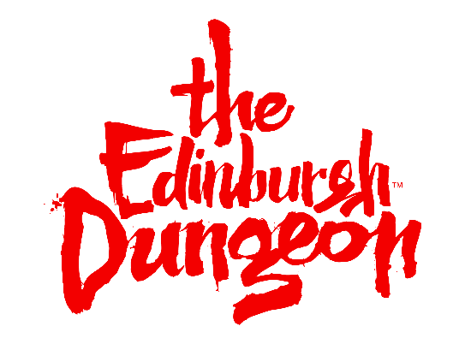
*The information/hazards have been identified as being inherent to The Edinburgh Dungeon.
The purpose of this document is to enable schools/groups to use the information provided for the development of visit risk assessments in order to satisfy the obligations placed by the Health and Safety at Work Act and the Management of Health and Safety at Work Regulations. Merlin Entertainment Groups Ltd does not accept liability for any omissions to this list. Control measures indicated are recommendations only and must be adapted/amended by group organisers. Please ensure adequate supervisors are appointed for the number in your group.

